ESJ GSP

Social Media Post Templates

Stay Informed for Workgroup

DATE | FACEBOOK
Our last Informational Meeting was a success! Please join us for our next meeting on November 7 from 6:30-8:00 at the Manteca Transit Center – 220 Moffat Blvd, Manteca, CA 95336. We will be there to answer any questions you might have!
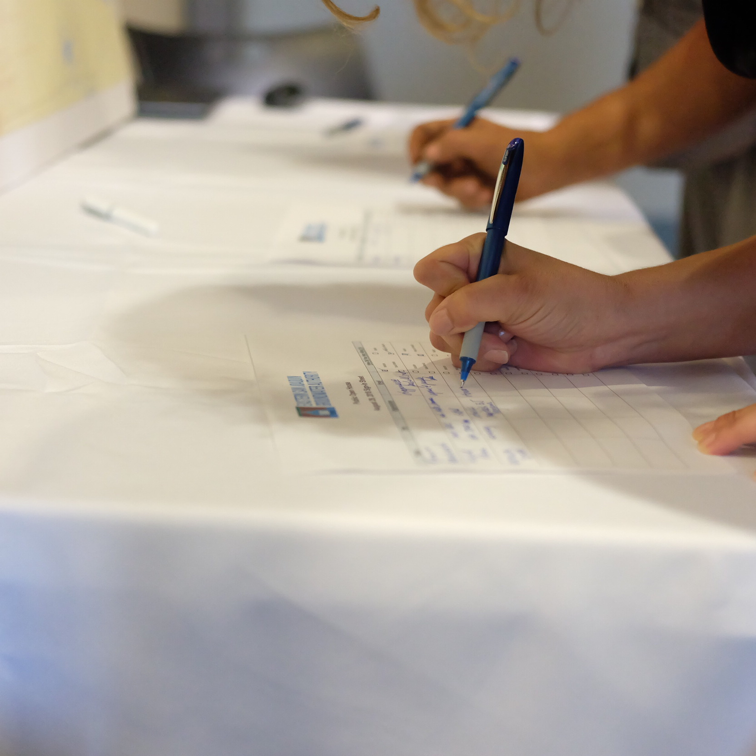
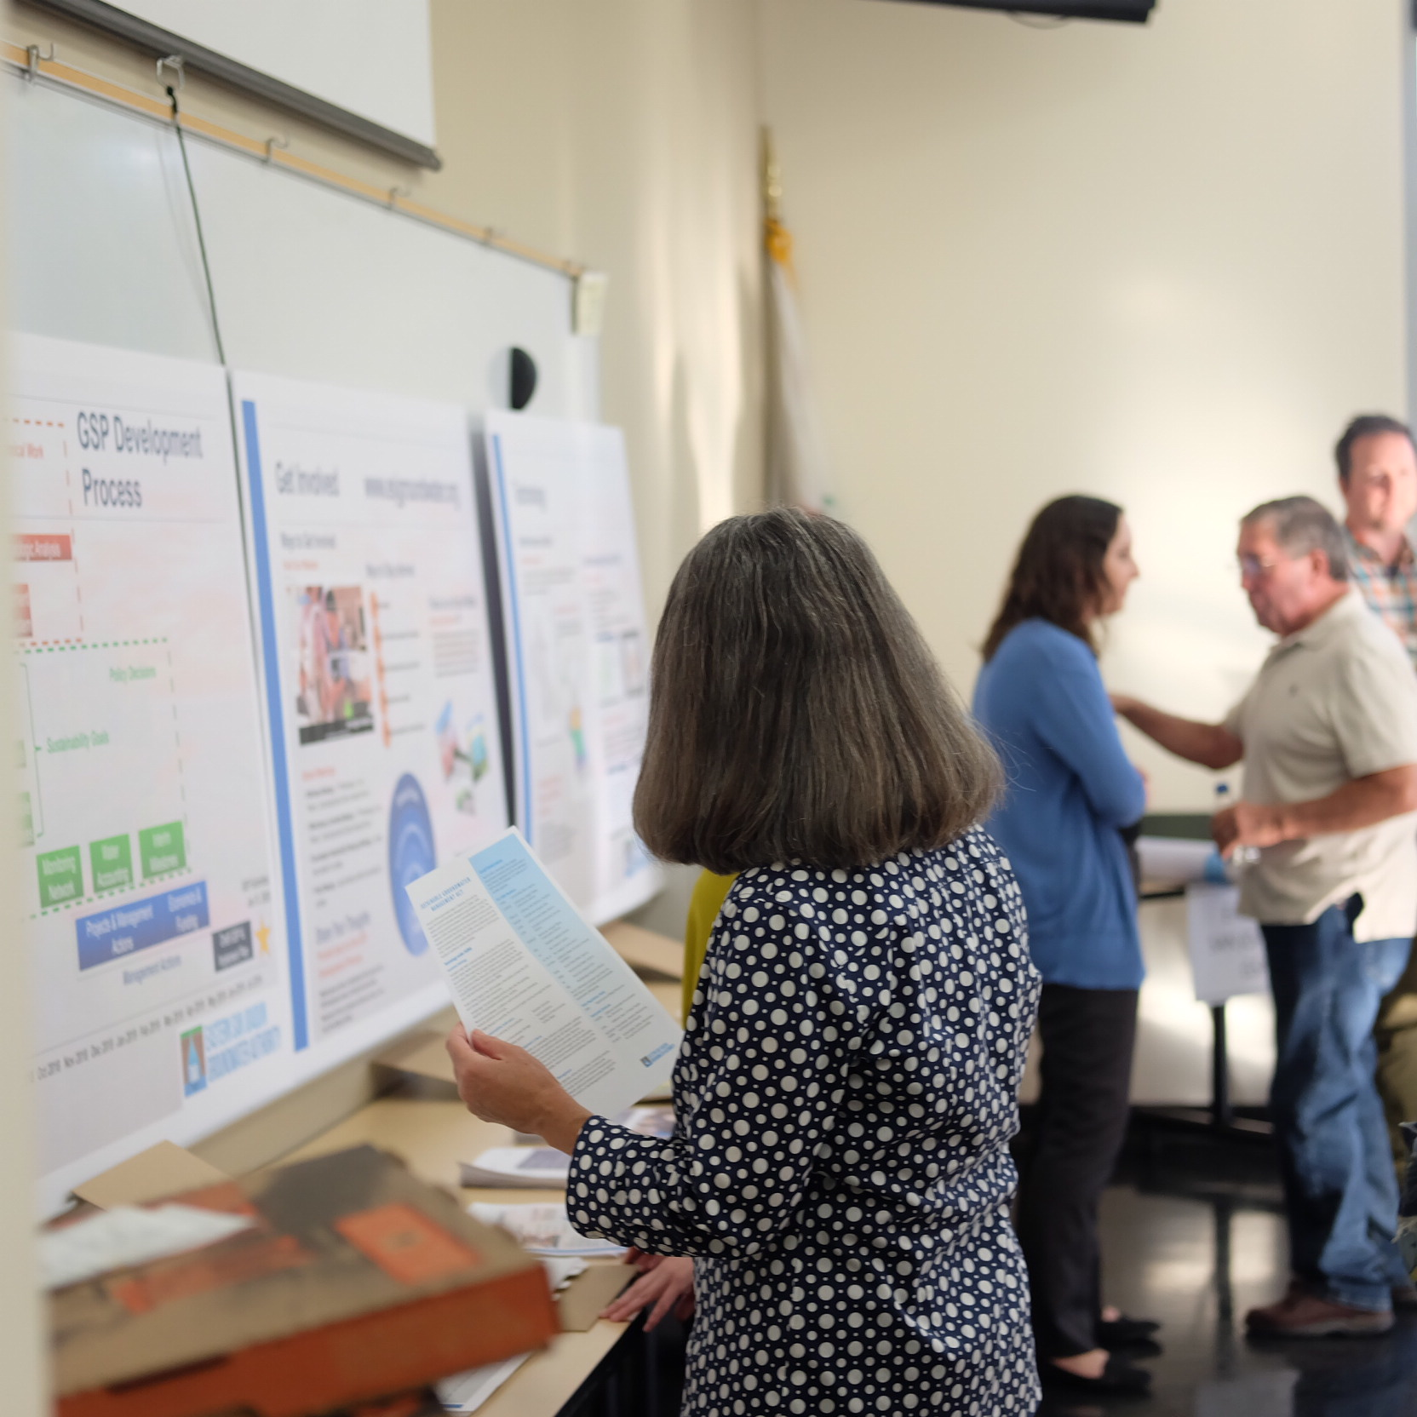
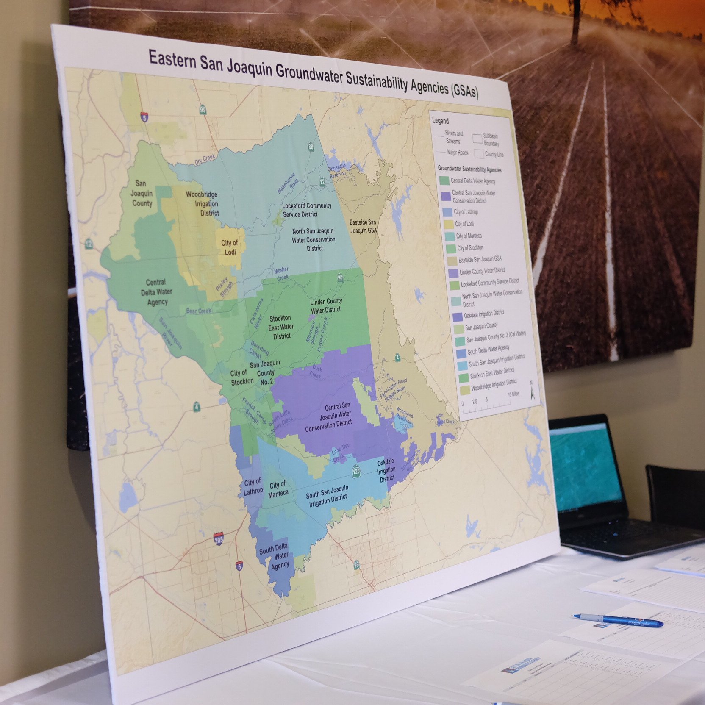
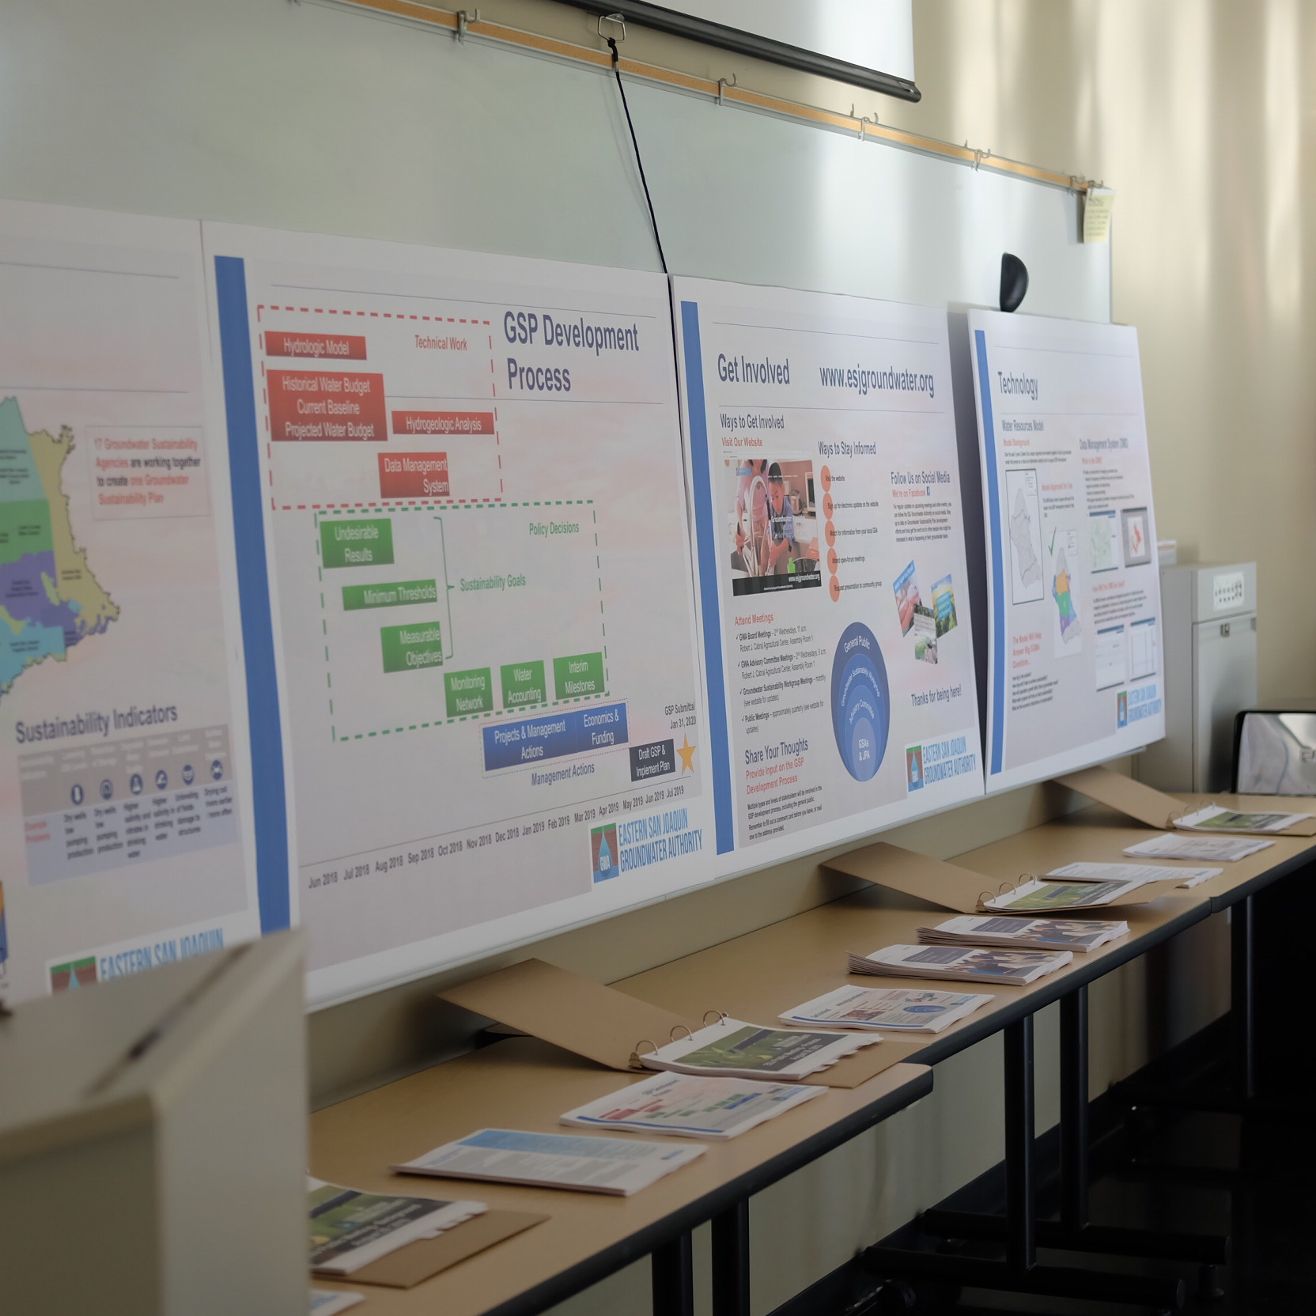

Can you find yourself on this map? If yes, sign up for our monthly newsletter that will give you updates on the Sustainable Groundwater Management Act and Eastern San Joaquin Groundwater Authority.

Sign up here: http://www.esjgroundwater.org/Get-Connected

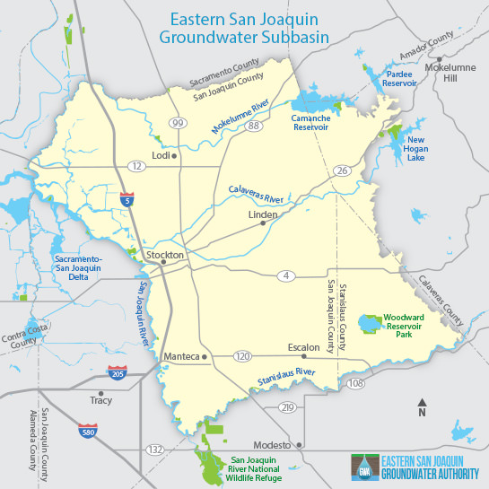

The California Department of Water Resources webpage lays out the ins and outs of the Sustainable Groundwater Management Act. Read more here: https://bit.ly/2xDNiOp!


