ESJ GSP

Social Media Post Templates

Stay Informed —August 31

DATE | FACEBOOK
Do you want to learn more about the Sustainable Groundwater Management Act? Visit: https://water.ca.gov/Programs/Groundwater-Management/SGMA-Groundwater-Management.

If you have any questions or comments, we will be holding informational meetings from now until Summer 2019. Future meeting dates will be available soon!



We have laid out the four main components of the Groundwater Sustainability Plan below. For more information, please visit: http://www.esjgroundwater.org/.

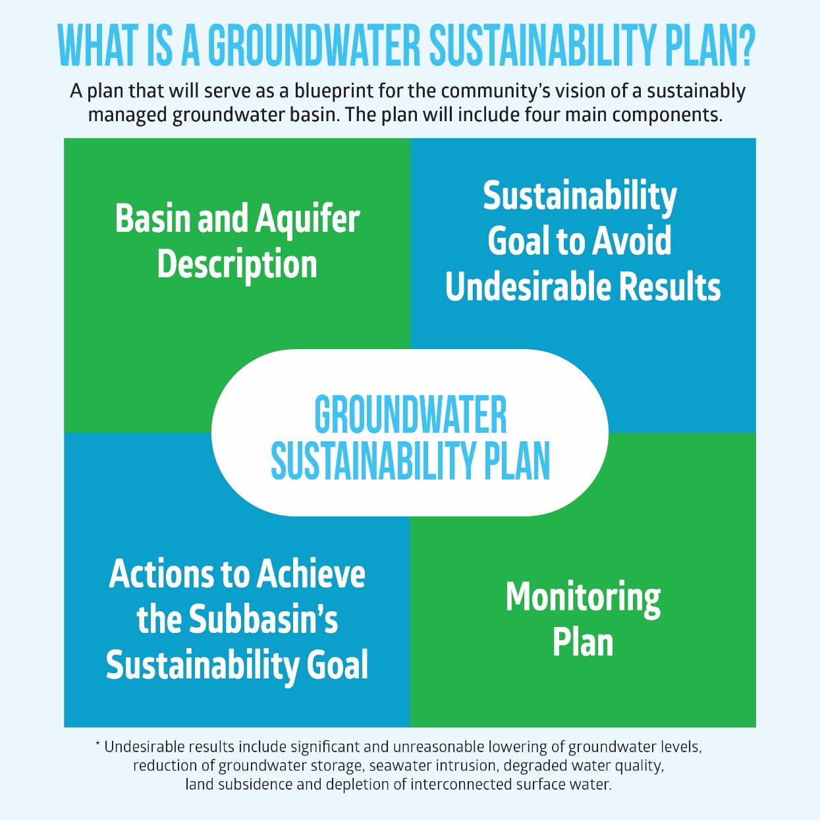

Are you looking for more information on the Sustainable Groundwater Management Act? Sign up for our monthly newsletter for updates from the Eastern San Joaquin Groundwater Authority.
Sign up here: http://www.esjgroundwater.org/Get-Connected
